**ROBO SOCCER**

A Non syllabus project

**Bachelor of Technology**

**I Year**

By

**Devanshi Sikhwal (PCE21CS044)**

**Devanshu Saini ( PCE21CS045)**

**Divya Agarwal (PCE21CS049)**

**Gaurav Kumar Roy (PCE21CS055)**

under the guidance of

**Ms. Sheena Khan, Assistant Professor, PCE**



(Session 2021-22, ODD Semester)

**Poornima College of Engineering**

ISI-6, RIICO Institutional Area, Sitapura, Jaipur – 302022

**February, 2021**

**CERTIFICATE**

This is to certify that the project entitled “ **ROBO SOCCER** ” has been carried out under my guidance in academic session 2021-2022. Following students of B.Tech. Computer Science (1st Year) have prepared the project:

1. Devanshi Sikhwal (PCE21CS044)
2. Devanshu Saini (PCE21CS045)
3. Divya Agarwal (PCE21CS049)
4. Gaurav Kumar Roy (PCE21CS055)

To the best of my knowledge and belief, the matter embodied in the project work has not been submitted elsewhere for the award of any other project work.

The work has been found satisfactory and is approved for submission.

Date: 16/02/2021 Ms. Sheena Khan

(**Project Guide)**

**AKNOWLEDGEMENT**

We take this opportunity to express our profound gratitude and deep regards to our guide Ms. Sheena Khan , Mr. Sugreev Choudhary and Zircon club members for their exemplary guidance, monitoring and constant encouragement throughout this project.

We also thank the blessing, help and guidance given by Dr. Mahesh Bundele, Director and Principal , Mr. Pankaj Dhemla , Vice Principal, Dr. Rekha Nair, Dean Academic , Mr. Shailendra Kasera, HOD 1st Year such helpful environment. We are also obliged to the faculty members for the valuable information provided by them in their respective fields. We are grateful for their cooperation during the period of our project.

We are also indebted to the authors of many references and articles which were used as the reference.

And also we would like to thank our friends and family for their help in every way for the success of this project.

**ABSTRACT**

The project demonstrate the working of **Robo Soccer** , a soccer playing robot for a war gaming for various recreational and competition purposes. The main aim of the project is to get an elementary knowledge about concepts and technologies in the broad interdisciplinary area of robotics as well as to get an experience in building a robot and to promote robotics in every field.

This project contains a description of background theory, construction process and the details of the parts with images. The Mechanical Engineering team will use solid works to create assemblies and create or update parts and drawings of the robot and will ensure mechanically fit design of the robot for the soccer game. The Electrical Engineering team will ensure proper schematic connections.

In this project we described the designing of a robo soccer team. This project shows the use of this team to strengthen the study of mathematics, physics, science by college students. Finally we show that these robots can be used to encourage the study of engineering.

**Content List Page No.**

Acknowledgement…………………………………………………………………………3

Abstract……………… …………………………………………………………………...4

1.Introduction

1.1 Project overview……………………………………………………………………….6

1.2 Project objectives……………………………………………………………………...7

1.3 Problem description……………………………………………………………………8

2. Methodology

2.1 Components required………………………………………………………………….8

2.2 Manufacturing processes……………………………………………………………..11

2.3 Robot dimensions…………………………………………………………………….14

2.4 Construction and working……………………………………………………………15

3. Future scope and applications……….…………………………...................................16

4. Conclusion……………………………………………………………………...……...17

5. Reference………………………………………………………………………............18

**1.INTRODUCTION**

**1.1 PROJECT OVERVIEW**

Robo Soccer is an event of soccer robots where we have to compete on an arena which is specially designed for a Robo soccer match. This event also tests your stability control, handlings, and your techniques in competing with your opponent. One who makes more goals than his opponent wins the round and is promoted to the next round of the event. The simultaneous movement rules encourage clever strategies and counterstrategies as players try to second guess their opponents.

So what actually happens in a soccer game is:

***Soccer***

Soccer or football is a one type of sport played between two teams where each team on the soccer consist of 11 players and plays with a spherical ball. Soccer is the world’s most famous sport played over 150 countries. Soccer game is played on a rectangular field with a goal at each end. The main concept of this sport is to score by getting the spherical ball into the opposite goal. The goal keepers stops the ball with their arms from the outfield players. When the team gets more score at the end of the match, then that match will be declared as a win.

***Robo Soccer***

Robo Soccer is a game played between two teams of the robot . Mostly, this is done with the Robo cup or different tournaments done each year.

Size of the robo team consists of two robots that is attacker and defender. The main motto of attacker and defender is to kick the ball and to prevent the ball from entering into the goal.

1. ***Defender* -** The main purpose of the goal keeper robot is to prevent the ball from entering into the goal. The problem that the goalkeeper solves is to detect the ball, calculate the ball positions, estimate its trajectory and predict a future point to intercept the ball.
2. ***Attacker*** - The main motto of the attacker robot is to collect the ball and throw it to the opponent’s goal post.

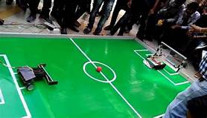

***Arena specifications :*** The arena consist of a rectangular table top of inner dimension 2000mm  × 1500 mm, colored ‘green’. The floor under the carpet is level, flat and hard. The table had the boundary of height 50 mm of top color white and side color green, same as that of the arena. Solid 7cm  × 7cm isosceles triangles were fixed at the four corners of the playground to avoid the ball getting cornered.

***The Goal Post and Goal Area* :**The goal posts are of dimensions 400mm * 150mm (L* B ). The goal post is a 3- D structure with its two surfaces of dimensions as above which are open, rest all the sides will be blue or red color. The goal areas shall comprise of the area contained by the rectangle sized 400mm*100mm in front of the goal post and are colored red and blue respectively**.**

***Penalty Area***

**The penalty areas shall comprise of areas contained by the rectangle sized 900mm*400mm in front of the goal. The penalty area contains the goal area. The field of a play is divided into halves by a halfway line. All line markings will be white in color and 25 mm thick. However, the markings of starting zones will not be done in the arena.**

**1.2 PROJECT OBJECTIVES**

* **Image processing for orientation of robots and components used.**
* **Design of both the bots, i.e. one attacker and one defender**

**1.3 PROBLEM DESCRIPTION**

**In Robosoccer challenge, maximum three manually controlled robots will compete against each other in an arena which resembles an actual soccer field.**

**The robot should be wirelessly controlled. Readymade robots are not allowed. The robot should have been fabricated, assembly by the team.**

**2. METHODOLOGY**

**2.1 Components required**

* **Chassis- Mildsteel metal (16*20)**
* **Motors – 300 RPM ( Johnson Geared Motor DC 12V) (Side Shaft)( High Torque) -8 (4 for each bot)**
* **Wheels – 8**
* **Wires (1.5mm) - 40m**
* **DPDT Switches and box**
* **L clamps – 8 (steel)**
* **Nuts and bolts**

**2.1.1 Chassis**

Chassis is the mechanical assembly or the base frame of the robot on which driving motors and wheels are mounted. This is very important part of the robot which gives shape and stability to robot. The material which is used is mildsteel metal. The motors and wheels are attached to the chassis with the help of nuts and bolts.

**2.1.2 DC Geared Motors**

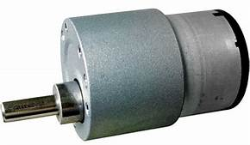Its is a simple DC motor featuring metal gearbox for driving the shaft of the motor, so it is a mechanically commutated electric motor which is powered from DC supply. The Johnson Geared Motors are known for their compact size and massive torque-speed characteristic. The Johnson Motor comes with side shaft also known as an off- centered shaft and six M3 mounting holes. The shaft of the motor equips metal bushes which makes these DC gear motors shaft wear resistant. These motors are best suitable with highly developing capable robots or robotic platform, various automation purposes.

**2.1.2.1 Features**

* 300 RPM 12 V DC motors with Metal Gearbox and Metal Gears.
* 6mm diameter shaft with M3 thread hole
* Gearbox diameter 37 mm
* Motor Diameter 28.5mm
* Length 63 mm without shaft
* Shaft length 30 mm
* 180 gm weight
* 9.06 cm holding torque
* No-load current=800mA, Load current=upto 7.5 A(Max)
* Recommended to be used with Dual DC Motor Driver 20 OR Dual DC Motor Driver 20

**2.1.3 Wheels**

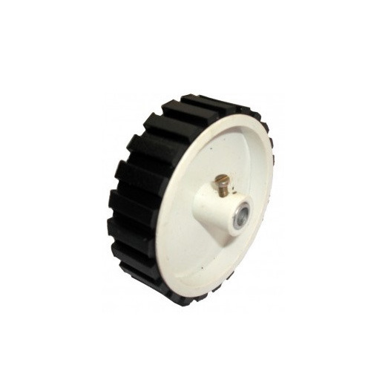A wheel is a circular object of plastic body used for maintaining the balance and moving the object efficiently. The wheel rim is made of robust plastic and outside covered with rubber and it is fixed on the motor shaft with the help of a screw.

**2.1.3.1 Features**

* Wheel Outside Diameter : 80 mm (3.15 inch)
* Wheel Thickness : 25mm
* Hole Size:6mm ; compatible with motor shaft of 6mm
* Loading Capacity : 2Kg+

**2.1.4 Wires**

A wire is a single usually cylindrical, flexible strand or rod of metal. Wires are used to bear mechanical loads or electricity and telecommunications signals. Wire is commonly formed by 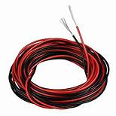drawing the metal through a hole in a die or draw plate. Wire gauges come in various standard sizes, as expressed in terms of a gauge number. The term 'wire' is also used more loosely to refer to a bundle of such strands, as in "multistranded wire", which is more correctly termed a wire rope in mechanics, or a cable in electricity.

Wire comes in solid core, stranded, or braided forms. Although usually circular in cross-section, wire can be made in square, hexagonal, flattened rectangular, or other cross-sections, either for decorative purposes, or for technical purposes such as high-efficiency voice coils in loudspeakers. Edge-wound coil springs, such as the Slinky toy, are made of special flattened wire.

**2.1.5 DPDT Switches and Box**

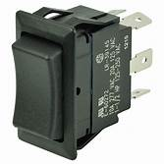A Double Pole Double Throw (DPDT) switch is a switch that has 2 inputs and 4 outputs; each input has 2 corresponding outputs that it can connect to.   
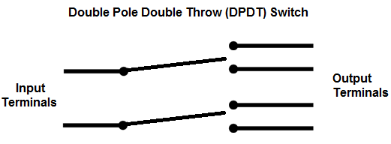

Each of the terminals of a double pole double switch can either be in 1 of 2 positions. This makes the the double pole double throw switch a very versatile switch. With 2 inputs, it can connect to 4 different outputs. It can reroute a circuit into 2 different modes of operation.

A Double Pole Double Throw Switch is actually two single pole double throw (SPDT) switches.

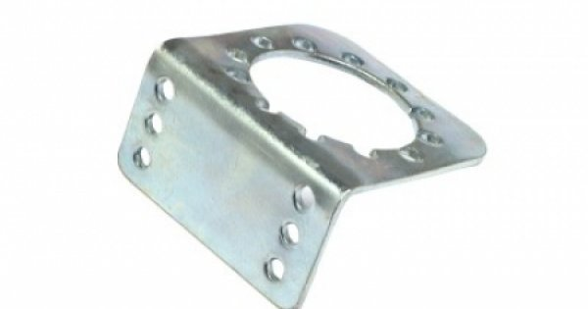**2.1.6 L Clamps**

A clamp is a fastening device used to hold or secure objects tightly together to prevent movement or separation through the application of inward pressure. In the United Kingdom the term cramp is often used instead when the tool is for temporary use for positioning components during construction and woodworking; thus a G cramp or a sash cramp but a wheel clamp or a surgical clamp.

There are many types of clamps available for many different purposes. Some are temporary, as used to position components while fixing them together, others are intended to be permanent. In the field of animal husbandry, using a clamp to attach an animal to a stationary object is known as "rounded clamping." A physical clamp of this type is also used to refer to an obscure investment banking term, "fund clamps." Anything that performs the action of clamping may be called a clamp, so this gives rise to a wide variety of terms across many fields. Here we are using L clamps.

**2.1.7 Nuts and Bolts**

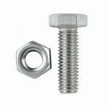A nut is a type of fastener with a threaded hole. Nuts are almost always used in conjunction with a mating bolt to fasten multiple parts together. The two partners are kept together by a combination of their threads' friction (with slight elastic deformation), a slight stretching of the bolt, and compression of the parts to be held together. A bolt is a form of threaded fastener with an external male thread requiring a matching pre-formed female thread such as a nut. Bolts are very closely related to screws.

**2.2 TOOLS AND TECHNIQUES USED**

**2.2.1 SOLDERING**

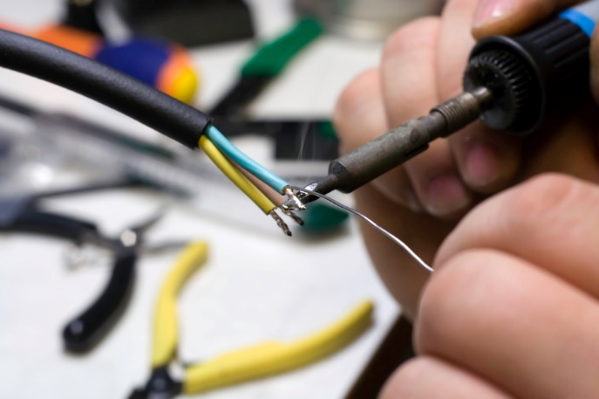Soldering is a joining process wherein coalescence is produced by heating below 800°F , using a non-ferrous filler metal with a melting point below that of the base metal. The metals to be joined dictate the flux, solder, and heating methods to be used. Base metals are selected for specific properties such as electrical conductivity, weight, and corrosion resistance. To achieve a sound soldered joint, the following should be considered:

• Joint design: They should be designed with the requirements of solders and their limitations in mind.

• Pre-cleaning: The surfaces must be thoroughly cleaned to allow the solder to wet the base metal.

• Fluxing: A flux must be provided to remove traces of surface film or oxides and to prevent formation of oxides during the soldering operation.

• Proper fixtures or alignment of parts must be maintained to insure a sound soldered joint.

• Heating of the base metals should be uniform or even on base metals, to insure good penetration of the filler alloy into the joint. If a noncorrosive flux is used no further cleaning is necessary. The use of a corrosive flux makes flux residue removal imperative.

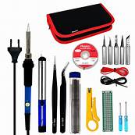**SOLDERING KIT**

Soldering iron kit comes with soldering iron, desoldering pump, 5 multiple soldering tips, tin wire tube, soldering iron stand, tweezers, wire stripper cutter, 2 electronic wire.

**2.2.2 WELDING**

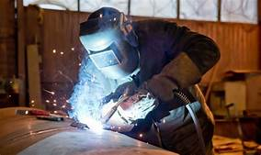Welding is a fabrication process that joins materials, usually metals or thermoplastics, by using high heat to melt the parts together and allowing them to cool, causing fusion. Welding is distinct from lower temperature metal-joining techniques such as brazing and soldering, which do not melt the base metal.

In addition to melting the base metal, a filler material is typically added to the joint to form a pool of molten material (the weld pool) that cools to form a joint that, based on weld configuration (butt, full penetration, fillet, etc.), can be stronger than the base material (parent metal). Pressure may also be used in conjunction with heat or by itself to produce a weld. Welding also requires a form of shield to protect the filler metals or melted metals from being contaminated or oxidized.

Many different energy sources can be used for welding, including a gas flame (chemical), an electric arc (electrical), a laser, an electron beam, friction, and ultrasound. While often an industrial process, welding may be performed in many different environments, including in open air, under water, and in outer space. Welding is a hazardous undertaking and precautions are required to avoid burns, electric shock, vision damage, inhalation of poisonous gases and fumes, and exposure to intense ultraviolet radiation.

**2.2.3 DRILLING**

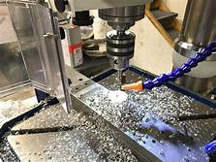Drilling is a cutting process that uses a drill bit to cut a hole of circular cross-section in solid materials. The drill bit is usually a rotary cutting tool, often multi-point. The bit is pressed against the work-piece and rotated at rates from hundreds to thousands of revolutions per minute. This forces the cutting edge against the work-piece, cutting off chips (swarf) from the hole as it is drilled.

In rock drilling, the hole is usually not made through a circular cutting motion, though the bit is usually rotated. Instead, the hole is usually made by hammering a drill bit into the hole with quickly repeated short movements. The hammering action can be performed from outside the hole (top-hammer drill) or within the hole (down-the-hole drill, DTH). Drills used for horizontal drilling are called drifter drills.

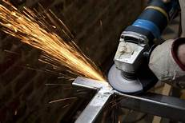**2.2.4 GRINDING**

Grinding is a method of reducing the size of hard materials or sharpening tools, generally accomplished in several stages. To produce desired fineness of end products, grinding is done after crushing. For example, through crushing the mineral ore to below a certain size and finishing by grinding it into powder, the ultimate fineness depends on the fineness of dissemination of the desired mineral.

Grinding can be done wet or dry, depending on the process in use, but for dry grinding the materials first may need to be dried in cylindrical, rotary dryers.

Many machines are used for grinding, including:

• Hand-cranked knife-sharpening stones (grindstones)

• Handheld power tools such as angle grinders and die grinders

• Various industrial machines known as grinding machines

• Bench grinders often found in residential garages and basements

Grinding can produce very fine finishes and very accurate dimensions. It is usually better suited to the machining of very hard materials than is "regular" machining.

Property changes due to grinding include:

• Martensitic layer may form on the part, which leads to reduced material strength from

micro cracks

• Possible loss of magnetic properties on ferromagnetic materials

• Increased susceptibility to corrosion because of high surface

Grinding machines remove material from the work piece by abrasion, which can generate substantial amounts of heat. To cool the work piece so that it does not overheat and go outside its tolerance, grinding machines incorporate a coolant

**2.3 Robot dimensions**

The robot can be circular or rectangular in style. Here we are showing rectangular style robot.

1. Width/Diameter- not more than 30 centimeter

2. Length- not more than 30 centimeters

3. Height- not more than 40 centimeters

4. Weight- upto 7 kg

**2.4 Construction and its working**

Robot consists of 2 levels .In which first level there is a metal chassis of size “20”,”16”.For smoothing of base grinding is done with the help of bench grinder. Then we do drilling to attach clamps. Then we weld the jaws both side of the bots .In attacker forward and backward both side jaws are attached whereas in defender jaws attached in only forward side. Which will help to catch the ball and defend it from goal. Then clamps are attached with the help of screws and screwdriver .Then we attached motors with the clamps in the same alignment so that our wheels of robo move in uniform direction .Then we attach wheels to the bots. Then we do the connections with the motors and check the polarity with the help of battery .Then for controlling we use DPDT switches which is also connected by checking polarity with the bots .We can move our bot forward ,backward ,left,right and can dribble the ball. Even we can rotate our bot and with the help of jaws bot can kick the ball.For power the motor we use direct power supply or power adaptor. After all these there is only one thing left which makes our bot attractive and that is finishing touch. For that we need to paint both of the bots and make a top structure on its second level. We can make it with the help of cardboard, fibre, thermocol or anything which can look good after the paint. Our structure design should be detachable and size should according to the bots.

**1.Motor connection**

First solder red wires to positive terminals of all DC motors and black wire to negative terminals of all DC motors

**2. Chassis connection**

Test each motor by connecting all red wires to positive terminal and all black wires to negative terminal to any external battery and then fix them in the chassis. Take the reds and black of left motors in check to see they are working or not and do the same with right motors.

**3.DPDT connection**

When both the switches are both pushed forward , the robot moves forward while when both switches are both pushed backward, the robot moves in backward direction. When the right switch is pushed , the robot turns right and when the switch is turned left , the robot turns left .

**FINAL PROJECT**

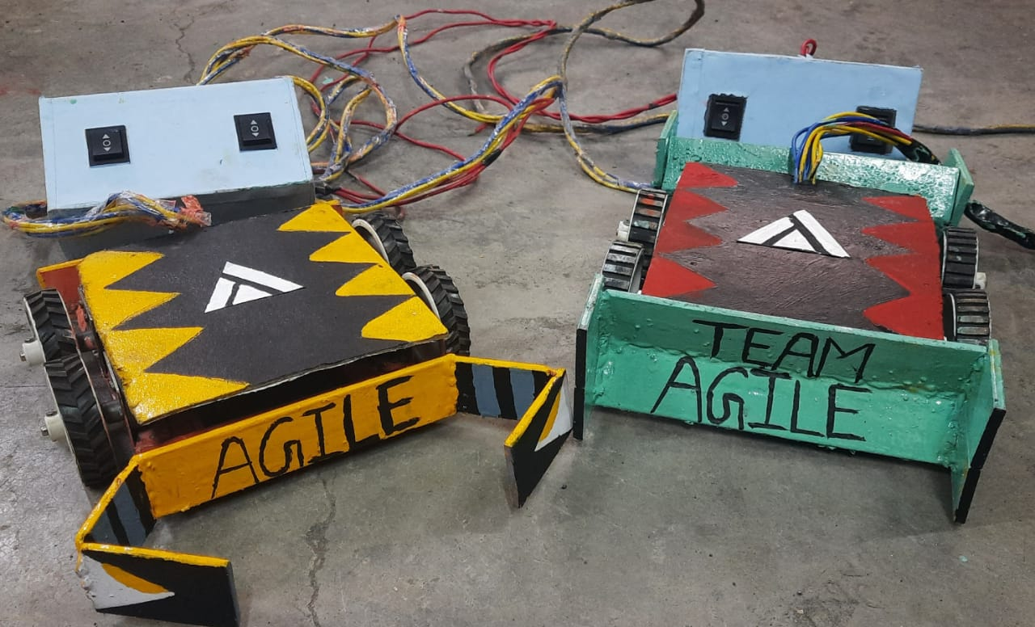

**3. Future Work and Applications**

* Recreational purpose - A soccer robot is a specialized autonomous robot and mobile robot that is used to play variants of soccer. It is a great attraction for younger students.
* Electrochemical point of view for cripple or paralytic people - Humanoid soccer players will help many cripple and paralytic people. The same algorithm used in the robots to run, walk,jump, kick and pick a ball is used to control these robotic prosthesis. With some more changes, the robotic prosthesis can be turned to even full body exoskeleton.
* Vision algorithm can be used for blind people - The vision algorithm and the cameras should be used to help blind people and to monitor everything. The image processing techniques used in the robots should be used to guide blind people in a crowded metropolis. The vision processing will be able to tell when an obstacle is approaching.
* Tracking algorithms to track vehicles on a road - Algorithms used to track vehicles in a road or the trajectory of any moving object, an anticipating possible collisions. Algorithms can be used in traffic military operations in armored vehicles and vehicles to avoid friendly fire.
* A controller is to be designed to control the robot
* Further improvements like appropriate mechanism for turning the robot, performing lateral motion can be implemented
* Prototype of this robot can be made in a robust way and test can be performed for performance and cost analysis.
* Building up the physical model by considering the results of testing phase.
* Further analysis can be focused on how to detect obstacles and generate path while moving . This requires artificial intelligence.

**5. Conclusion**

This project successfully met almost all its initial goals. The soccer competitions is more than just an attraction for students and media and more than one place to test hardware and software outside the laboratories. The research done to create a fully autonomous soccer robots for further work can really be applied in many useful robotic applications to the mankind.

From prosthesis and orthosis to cripple, passing to image processing algorithms which can save lives and arriving in multi-agent cooperation algorithms and decision making which will optimize the actions of squardons or even swarms of robots or intelligent agents, the researches in robotic soccer can really allow and foster the development of powerful robotic applications.

Overall, the project was successful and the robots could effectively play the game of soccer.

**6. References**

1. Rodriguez S., Rojas E. (2010). “*Diseno e implementacion de un equipo Small size robot league para la Robocup,”* Technical report, Universidad Santo Tomas, Electronic Engineering Faculty, 2010.
2. Srisabye1J., WasuntapichaikulP., Onman Ch., Sukvichai K., Damyot S., “*Skuba 2009 Extended Team Description”.*
3. Turic H., Plestina V., Papic V. and Karol A. (2010). “*Robot soccer educational courses”.* Robot Soccer. InTech , January,2010,pp 101- 120